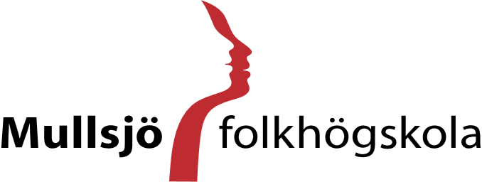

Community, creativity and participation

About the School and the Area
Mullsjö folkhögskola is a Swedish folk high school located in the town of Mullsjö, a small and welcoming community in southern Sweden with approximately 5,000 residents. Mullsjö is located about 30 kilometres from the city of Jönköping, with regular train and bus connections that allow easy access to a wider range of services, shopping, and cultural activities.

Folk high schools are a form of adult education unique to the Nordic countries, open to participants aged 18 and above. In Sweden, there are approximately 150 folk high schools offering a wide range of educational opportunities. Mullsjö folkhögskola welcomes around 120–150 participants each year, most of whom are between 20 and 25 years old. The school offers on-campus accommodation with approximately 64 boarding places, allowing many participants to live at the school while others commute daily. Meals are served in the school dining hall during weekdays, and the campus provides common areas, a sports hall, and gym facilities that support both learning and well-being.

The school offers several long-term courses running from August to June. The General Course enables participants to complete or supplement their upper-secondary education and includes two profiles: Basic, which provides flexible learning with additional academic support (often for students with neurodevelopmental differences), and Human and Society, which includes studies in psychology, philosophy, and social sciences. Additional vocational and specialized programmes include Social Pedagogy, Architecture and Building Conservation, and KRIK, a programme focusing on Christian faith, health, and physical activity. Swedish as a Second Language courses are also offered in the nearby city of Jönköping.

Creative education forms an important part of the school’s profile. Artistic programmes are offered in ceramics, textile design, and visual arts. Guest teachers regularly contribute to the programmes, and participants present their work in exhibitions within the school’s shared spaces. In addition to long-term courses, the school offers a range of short courses and distance courses in subjects such as sculpture, mixed media, textile printing, writing, and music.
Mullsjö folkhögskola promotes a holistic approach to education that emphasizes academic learning, creativity, personal growth, and community engagement. The school’s activities are guided by a Christian value foundation and take place in a drug-free environment.

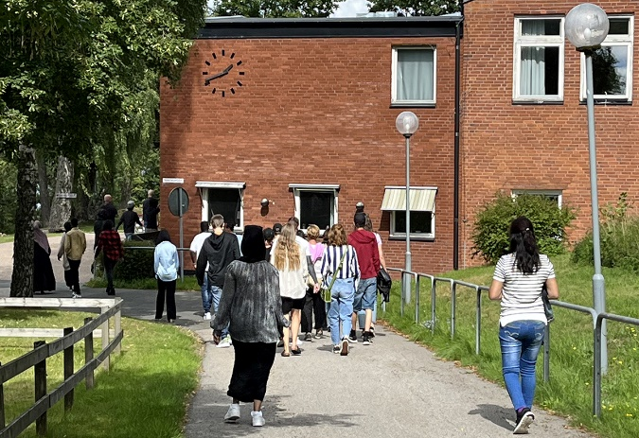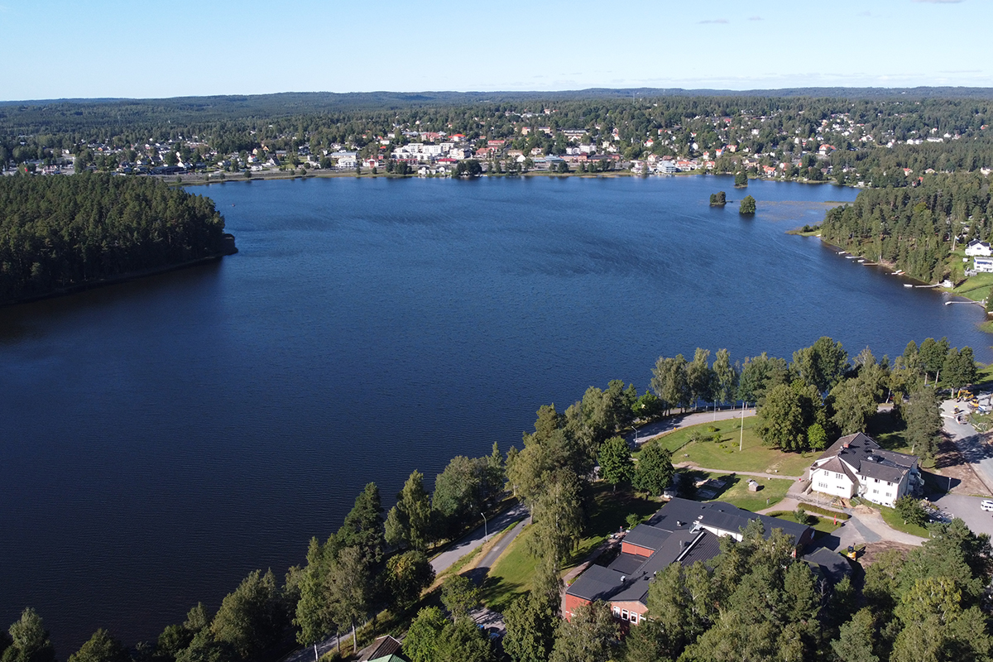

The volunteer Role
Volunteers at Mullsjö folkhögskola are an important part of the school community and contribute primarily to its social and communal life. The role focuses on supporting inclusion, building positive relationships with participants and being present in everyday school life. Volunteers will help create a welcoming environment where the students feel seen and included, especially those who may benefit from extra social support. In addition to their main role, volunteers may also take part in selected classes and activities, gaining insight into Swedish folk high school education and daily community life.
At the beginning of the term, volunteers take part in introductory gatherings where they learn more about the students and their interests. Based on this, they are responsible for organizing a weekly social activity called “Wednesday Hangout,” held on Wednesday evenings. These activities are typically planned together with other students and may include games, sports, film evenings, or creative workshops.
The volunteer role also includes assisting in Café Bernhard during weekday mornings, maintaining cleanliness in the café area, and working the cash register. They are also responsible for leading a short reflection gathering (“Andrum”) once during the autumn term and once during the spring term. There’s also the opportunity to take part in student council meetings.
In addition to this, volunteers is encouraged to lead one lesson per week within the General Course, depending on their own interests and background. This could include language practice, presentations about their home country, or other topics they feel confident sharing. Volunteers also have the opportunity to participate in selected classes across the school if they wish to explore specific subjects.
Throughout their stay, volunteers are encouraged to communicate in English while also supporting participants who wish to practice language skills. At the same time, they have the opportunity to learn and develop their own Swedish skills in everyday interactions.
Further tasks may include supporting boarding staff when needed, assisting with office work, contributing to course and conference activities, and occasionally helping in the kitchen. Across all tasks, volunteers are encouraged to take initiative and contribute their own ideas, particularly in developing leisure and social activities.

Overall, the volunteer role at Mullsjö folkhögskola combines social engagement, practical responsibilities, and opportunities for learning, offering a meaningful way to take part in everyday school life while contributing to a supportive and inclusive community.

Examples of tasks:
- Build relationships with the students and contribute to an inclusive and supportive community
- Communicate in English and support informal language exchange (English/Swedish)
- Organize and lead the weekly “Wednesday Hangout”
- Lead two short reflection sessions (“Andrum”) during the year
- Work in Café Bernhard four mornings per week, including serving and basic café duties
- Participate in student council meetings
- Assist staff when needed (boarding house, office work, course/conference activities, or kitchen support)
- Lead one weekly lesson in the General Course based on personal interests or background
- Contribute with own ideas and help organize voluntary leisure activities in the afternoons and evenings
- Document daily life and experiences as a volunteer through different media formats (e.g. photos, video, or written content)



Volunteer Profile
Volunteers at Mullsjö folkhögskola should be motivated to take an active role in a small, close-knit school community where social interaction is central to daily life. The role suits individuals who are creative, open, responsible, and interested in working with people in an educational and residential environment.
We are looking for volunteers who are socially engaged and approachable, with a genuine interest in building positive relationships with young adults from different backgrounds. The ability to take initiative, show empathy, and notice when someone may need support is important, as a key part of the role involves contributing to an inclusive and welcoming atmosphere.
Since communication is an essential part of the position, volunteers should feel comfortable using English in daily interactions. An interest in learning Swedish is also important, as language exchange naturally takes place in everyday life.
Overall, the project suits someone who enjoys working with people, likes leading activities, values community life and is interested in experiencing Swedish folk high school culture in a hands-on and meaningful way.

Work-scheduale and team
Volunteers are part of the daily life of the school and work in close cooperation with teachers, boarding staff, and other employees. They are supported by a designated supervisor who provides guidance in planning activities, coordinating tasks, and adapting to the school environment.
Volunteers are mainly active during weekdays, with a mix of morning, daytime, and occasional evening activities.
Working hours follow ESC guidelines and amount to approximately 35 hours per week, typically from Monday to Friday. The schedule includes time for preparation, participation in activities, and informal interaction within the school community.
Volunteers are entitled to two days off per week, as well as 24 days of holiday over a 12-month period (two days per month), in accordance with ESC standards.
Volunteers are also encouraged to take part in Swedish language learning as a way to support their integration into Swedish society. The amount of time dedicated to language learning is agreed upon together with the supervisor and can be adapted to the individual’s needs and interests.

Accommodation and Facilities
Volunteers are accommodated on the school campus together with other participants and students. Mullsjö folkhögskola has an on-site boarding facility (internat) with approximately 64 rooms. Some participants live at the school, while others commute daily. Living on campus provides opportunities to become part of the school community and to interact with participants outside of lesson hours.
Meals are served in the school dining hall during weekdays. Breakfast, lunch, and dinner are served from Monday to Thursday, while breakfast and lunch are served on Fridays. The school campus offers several shared facilities, including common rooms where participants can meet socially, a sports hall, and a gym. Participants in aesthetic programmes have access to their studios during evenings and weekends, and volunteers are welcome to participate in social and recreational activities within the school community.

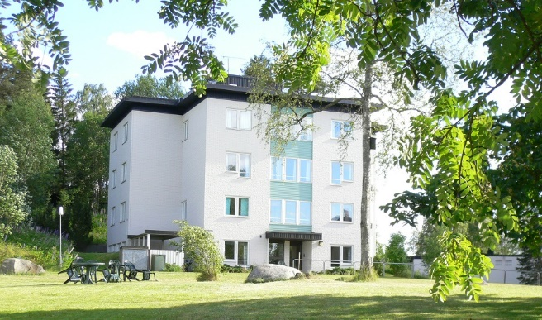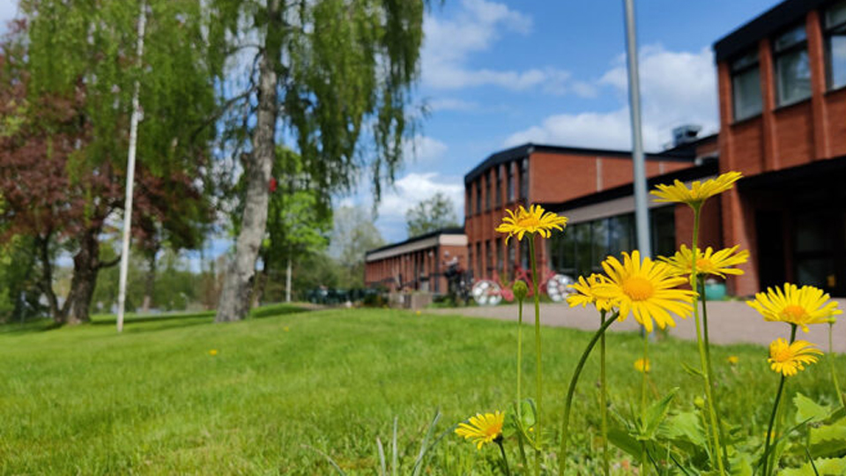

Leisure and Free Time Activities
Mullsjö offers a variety of opportunities for outdoor and social activities. The surrounding forests and nearby lake Stråken provide excellent conditions for hiking, cycling, swimming, and fishing during warmer months. During winter, the area is well known for cross-country skiing, with maintained ski tracks accessible close to the school.
Within the school community, social life is an important part of daily life. Volunteers and students have many opportunities to get to know each other and take part in shared activities such as school events, celebrations, performances, and community gatherings. Throughout the academic year, a variety of cultural and social activities are organized, including film evenings, sports activities, and other group events that contribute to a supportive and inclusive environment focused on personal development, creativity, and community.
Volunteers also have access to the school’s facilities during their free time, including common rooms, the gym, and the sports hall. These spaces can be used for informal sports activities, exercise, and social gatherings.
In addition to activities at the school, the nearby city of Jönköping offers further leisure opportunities, including shopping centres, museums, cinemas, cafés, and cultural events.

Travel Information – How to Get to Mullsjö
The town of Mullsjö is well connected by public transport. Regular train services operate between Mullsjö and the nearby city of Jönköping, with travel times of approximately 25–30 minutes. From Jönköping, further train and bus connections are available to major Swedish cities such as Gothenburg and Stockholm.
International volunteers typically travel to Sweden via one of the main airports, such as Göteborg Landvetter Airport or Stockholm Arlanda Airport, and then continue by train to Mullsjö. Detailed travel instructions are usually provided before arrival.

Check out blog posts from former volunteers in Sweden and Mullsjö:

Silvia and Lena-Maria, 2024/25: Knowledge and education for all
Paula, 2025/26: Do it for the plot
Gaia, 2023/24 Cultural differences between Italy and Sweden
Marie, 2023/24: Kanelbulle-territory
Océane, 2022/23: Midsummer in Sweden

